Operation Go Haiti (5th visit)

February 8, 2014 with blizzard conditions, we, (seven of us) took off for Chicago O’Hare field to serve on the fifth Operation Go Mission Trip to Haiti. We boarded the flight to Fort Lauderdale, FL where we would have an overnight layover, and had a smooth flight until landing. Due to the brakes not working (flippers) on the plane, we were told, by the pilot, that we were to have a hard landing. There was the chance that we would blow a tire upon landing. We unloaded the fuel to make the load lighter and the flight attendants told us when they called Brace, Brace that we were to put head down for the landing. We all prayed, lead by Mike, and our prayers were answered, by a safe landing. Upon disembarking the plane, we saw all of the fire equipment, ambulances and police waiting for our flight to come in. Thank you God.
February 9, 2014 we arose early for our flight to Haiti. This was a smooth flight and we arrived at the Guest House of Pastor Renes. After a light lunch, we took balls, sun glasses to the Choaids’ Orphanage and played with the children. They were all so happy to see us. We ran all sorts of races, jumped rope, played catch and threw the football back and forth. We listened to music and danced. Angela was ill with either a glandular or a tooth issue and wanted to be held. She was to see a dentist the next day.
It is with much joy to see the children so healthy and active. Much different than when we saw them for the first time four years ago. God is good.
The men did a survey to see what would be needed in lumber and equipment to complete their jobs of building shelves, cabinet doors and bunk bed support.
Returned to the quest house to Vivian’s great dinner and early to bed for some of us.
February 10, 2014 we awoke and had our Bible Study and learn of today’s agenda.
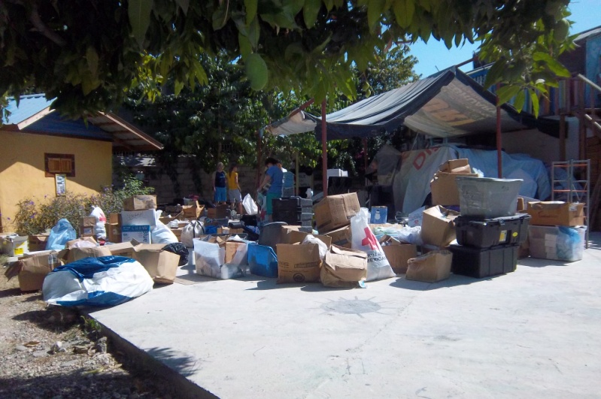
The tap tap arrived and we were on our way to the HC Center where we were to sort through the medical supplies. These supplies were stored in a container on the upper level and we were to remove the back half and discard the supplies that were outdated or no longer needed. To get the items out we had to take them down a narrow aisle and then down the steps or drop the items down to ground level to an individual. We formed a chain gang and tossed the items from one to the other and then down (95 degree heat), it was hot. The day was spent going through the items, throwing away or packing back up and taking the items back up into the container. It was very much appreciated.
While at the HC Center we learned of another orphanage, and feel that this was God orchestrated. The contact was made and a visit was set up for tomorrow.
February 11, 2014 after the Team Meeting and Bible Study, we had breakfast and then to the orphanage. We enjoyed the children their and saw a great need. There were a number of orphans 5 and under. We did provide them with a month’s supply of food and see a need for more help. This orphanage evidently practices Voo Dooism. They had a monument and a candle lit, with the Voo Doo Bible or book, and the Voo Doo dolls displayed. We prayed over the staff before leaving. This may be our third orphanage that we sponsor.
Our contact, Fan Fan II, had another orphanage that he worked with, that we will visit tomorrow.
We than went back to the Choaids’ Orphanage, where the children were out of school. We let each one pick out an outfit of clothing and then we had them color or cut out a Valentine. We played more games with them and the girls love to do hair or braid hair, especially a white person’s hair.
The men went shopping for the materials needed for the repair work they planned.
Jim had a very successful first day of teaching a Business Plan. He had about 20 students.
February 12, 2014 after our Bible Study and Team Meeting, Jim went to teach the class, Mike and Brett went to the orphanage to work on the shelves etc, and the women went to visit the third orphanage.
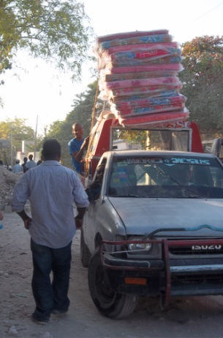
This orphanage had a very emotional response for us. The people that run it are running it on faith. They are dedicated and very loving to each child. They are in need of mattresses, vitamins, food, clothing, help and toys.
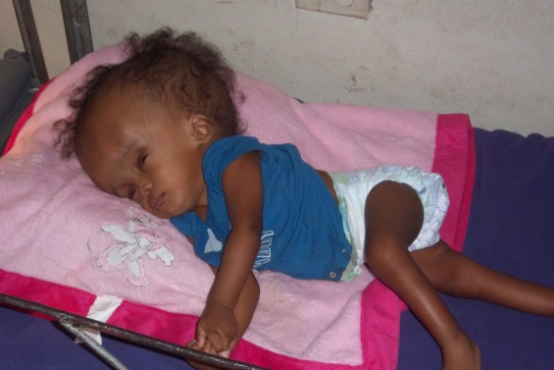
They had a child dropped off at their gate a couple of weeks earlier. This child is a hydrocephalus child, and the love the care giver shows this child is awesome.
They also have a child who has a hip issue and is stiff from the hips down. He is not able to sit or crawl. He is in need of exercise.
Another child is unable to crawl or walk. He just sits and makes no attempt to crawl. However, a happy child.
The other children, from 7 months up are all well behaved and all in need of love and affection. We fell in love with this orphanage and felt it was God’s leading us. We did purchase mattresses, a stove and a month’s supply of food for them.
While we were there, there was a father who brought his child in and left him at the orphanage and said that he was not able to care for him any longer.
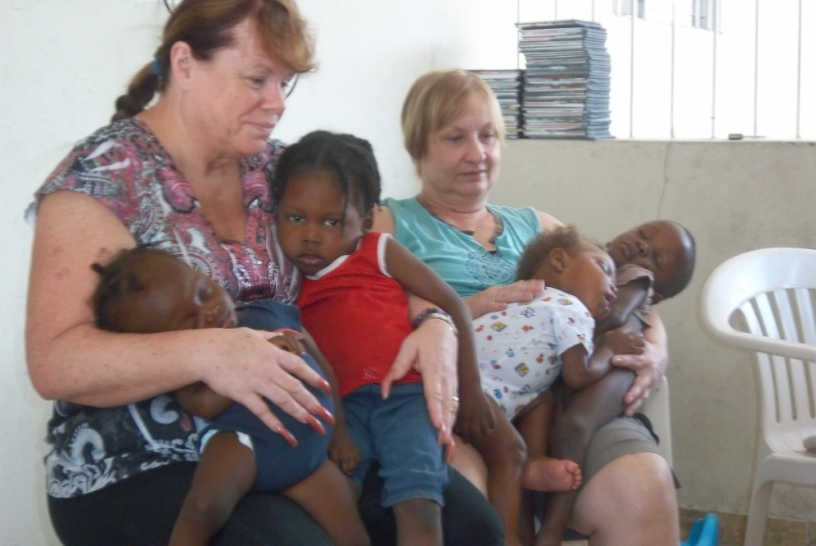
Some of the children do have a single parent and like the father above, have no way to provide for them.
We felt much sadness to see the children malnourished, much smaller than they should be for their age and behind In motor skills.
We returned to the Choaids Orphanage and took the children to the park for exercise. They do not get enough exercise since they are restricted to the small area included in their yard. We encourage the help to take them to the park a few times a week.
We were invited to Fan Fan’s (in charge of Choaids) home for dinner this evening. Great meal and enjoyed his grandmother.
February 13, 2014 after Bible Study and the Team Meeting again Jim went to his class, Mike and Brett to their work and the girls to the new orphanage.
On the way to the Orphanage we purchased an Infant Seat for the Hydrocephalus child, so that he could be in a different position than just laying. We also purchased a Baby Jumper so that the child with the hip issue could move around, get exercise and not just lay, as well as for the child that does not crawl.
The Hydrocephalus Child was to see a doctor on Saturday, and to use our Tap Tap to get him there.
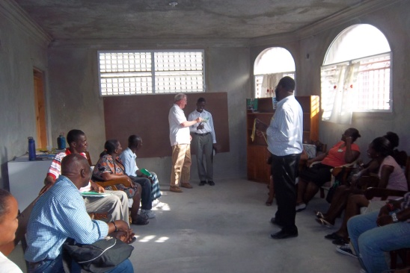
The afternoon was spent judging the winners in the Business Plan workshop. The winner was a woman who wanted to grow her restaurant business and the runner up was a gentleman that wanted to start a computer business. We provided $200 for first place winner and $100 for the second. They are all winners, because they each came into the workshop without the knowledge of a Business Plan and now there are 20 people who have this knowledge. They are all the future of the New Haiti.
The woman that won the first place shared her winnings with another member.
This was a very successful workshop. Pastor Renes was happy with the outcome and Jim was much applauded for the class.
February 14, 2014 began with our Bible Study and Team Meeting as usual. This is the day that we take the children to the beach. They do not get to experience a day out such as this, unless we provide it.
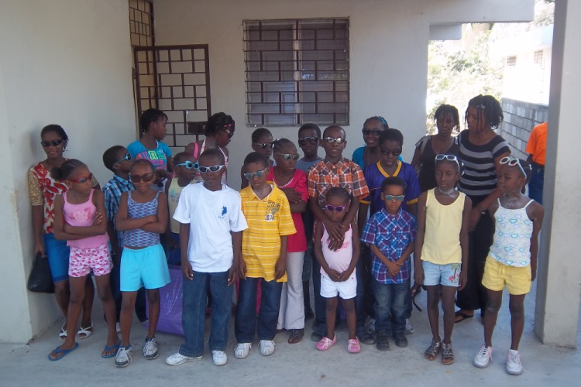
We had decided that we would take both orphanages to the beach on this day if we could get a bus and that it would be only the older children from the second orphanage. We were able to get the bus but evidently there was a miscommunication with the second orphanage. When we got to the orphanage all of the children, including the Hydrocephalus child and the child with hips issues were ready to go. We had 45+ children to go to the beach and we realized that the caregivers wanted a day of relaxation also.
After the children were in the water for a while we served them hot dogs and smores made over an open grill. The children loved them.
We had a wonderful day and our prayers were answered with no injuries, no bad sun burns and no travel issues.
When we took the Choaids Orphans home, it was our final time to see them. We had a Valentine bag for each of them and they had a song and a prayer for us. There were many tears shed as we said our good-byes.
February 15, 2014 the day to depart. Our host Pastor Renes and Monique, our cook Vivian and others joined us for prayer and we were off.
When we landed in Fort Lauderdale, FL we had a long layover. We found a nice restaurant where we had a great debriefing session as an Operation Go team.
There is a need for support for these orphanages and the vision of Pastor REnes’, A New Haiti” with the Business Plan Workshop. We are looking for support in both endeavors.
Operation Go, 160 High Street, Mineral Point, WI 53565.

