Haiti Mission Trip November 25-December 3, 2011

Thank you to all who supported us with prayers, finances and supplies as we experienced one of the most powerful, rewarding, emotional, spiritual and fulfilling Mission Trip. Our team bonded as a team, with our hosts, our drivers, our interpreters and the children, making it a very special trip.
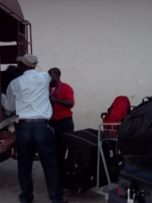
We left our homes around 4:00 AM on Friday, November 25th and had a safe trip from Chicago, IL, with connection in Miami to Haiti. We landed in Haiti and had a quick experience through customs. Our Haitian drivers, interpreters and hosts were waiting for us with hugs and greetings. They got our many bags loaded on the truck and we were on our way to Pastor Renes and Monique Deciere’s Guesthouse where they had a meal prepared for us. We were tired and ready for bed, after a team meeting that evening.
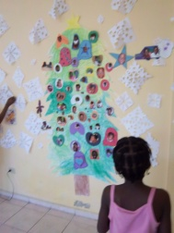
On Saturday, we were able to walk to the Orphanage, where some of our team members stayed and played with the children with a Christmas Theme, by coloring a large Christmas tree (put on the wall) and then made ornaments with their pictures on them to hang on the tree. They also made snowflakes and Christmas pictures from a coloring book to put on the wall. Later the children and team members made a snowman that they enjoyed so much since they do not know what a snowman is. They were very excited when they found one in the coloring book.
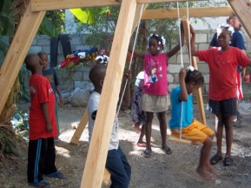
The other team members went shopping for the materials needed to build a chicken coop and swing set for the children, now that they have a home with a yard to play in, that is supported by our team. Once we returned we worked on the coop and swing set. (Before we left Haiti, we found a nest where one of the chickens was setting on 7 eggs).
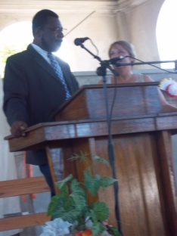
On Sunday, we attended church at Pastor Renes’s Church at AFCA. During the service he introduced us and we explained our Mission in Haiti. After the introduction, part of our team went with the children of the church and made bracelets. Pastor Renes asked Marie (director of the Orphanage) to interpret the service to the other members of our team.
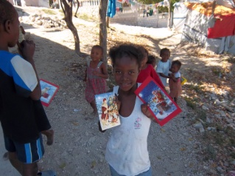
After church service was over, our team members and children of the church distributed Christmas Cards and invitations throughout the tent city, to attend The Nativity Story movie that we were playing that evening at the church. While distributing the invitations we met Kirby, who we have been supporting with, chickens, chicken feed etc and have built a chicken coop for him. His flock has grown from the 3-4 we purchased to 18 chickens since March and he has had eggs for food.
After lunch the team members sorted the supplies that we carried with us. We had supplies for the guesthouse, the orphanage, the Children’s Hospital, the clinics, Pastor Maxeus’s Church and Christmas Gifts for the children in the Orphanage.
That evening we had a great turnout for our movie and great appreciation was shown for it. Before the movie we passed out Candy Canes and explained the story of the Candy Cane. After the movie, Pastor Renes had a prayer and asked if there were any that would like to accept Jesus into their hearts. Twenty one children raised their hands and came forward. Two of the children were from his church and the others were from the Tent City that surrounds the church. Pastor Renes stated that he will follow-up with each one and that it was a blessing and God’s plan that the movie was offered.
On Monday, part of our team visited the Grace Children’s Hospital and others worked on completing the swing set and the chicken coop at the orphanage.
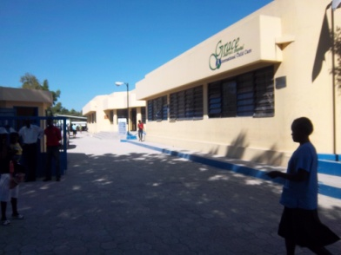
We toured the Hospital, where the earthquake had destroyed most of it and it has been rebuilt. We took the supplies, (medications, clothing, blankets and sheets) that we had collected for the hospital and gave them to the Director that gave us the tour. They are so busy, within the city of over 2 million people. The eye clinic now has only one doctor and services 75 persons per day. Every waiting area was filled to overflowing with patients. We met a doctor on the tour who works with children with disabilities and autism. Vivian (the cook from Pastor Renes’s guesthouse has an autistic son and they are beside themselves how to care for him). We asked about this and on our next visit took Vivian with us and we met again with the doctor who will now call on Vivian at her home and will offer support for her son.
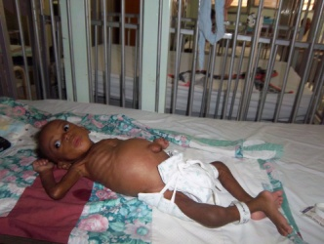
We spent some time with the children in the Hospital and passed out gifts to each one. We held the babies and fed them and prayed over them. Two of the babies were very mal-nourished, had TB and Scabies. People feel that they are not able to afford to bring their children to the hospital and they let the problem become too severe. Most babies there have no visitors due to distance or other issues. There was an older girl who had epilepsy who was dropped off at the hospital 5 years ago and never picked up or visited.
We returned to the Orphanage where part of our team went out to purchase needed beds, table and chairs for the orphanage as it expands with children. We also purchased a desk for the office. Others played with the children.
After completing the swing set and chicken coop the men worked on the water pump that was not working. This was not repairable so we purchased a new one for them.
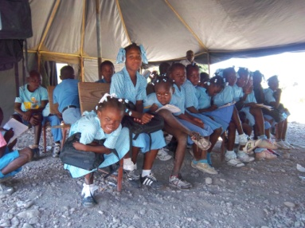
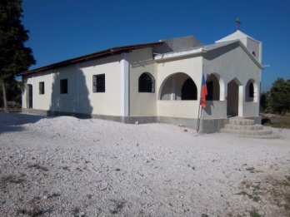
After a great breakfast at the guesthouse, we went on a long, bumpy trip out to Pastor Maxeau’s church in Bernard, Haiti, at the foot of the mountain. Pastor Maxeau had a vision and started a church and school in this remote area. They have dug a well, 145 foot deep by hand in this area for water for the church and school. The children meet for school in a large tent and what a heartwarming site to see 100’s of children in their clean and neat uniforms and hair done so nicely. Here again we passed out gifts for the children, along with the Candy Canes, with story, and showed the movie (the Nativity Story) in the church. After the movie Pastor Maxeau had a prayer and also asked if any of the children would like to ask Jesus into their heart. Twenty Six children came forward and he will follow up with them.
While there it was brought to our attention that there was a young girl who was in pain. Our nurse on the trip checked her out and realized that evidently she had a broken arm that was wrapped with a bark brace and cloth. We brought this to the attention of Pastor Maxeau and offered to pay to have the arm checked out by a doctor. This was done and before we left Haiti we were notified and saw the x-ray of the arm that it indeed was broken. This was casted and taken care of by our team. Had we not been there at that time this child would never have the use of that arm.
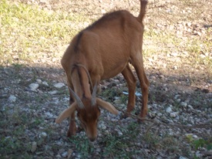
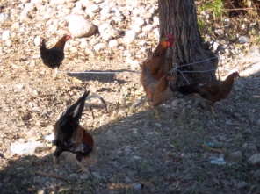
Pastor Maxeau has wanted to start a chicken business at the church, where they would have meat and eggs for the members. Our team worked with the Haitians to start a foundation for a coop and we purchased some chickens for a start and a goat. Pastor Maxeau stated that he would like to raise some goats so that each family of the church would eventually have a goat. We left money’s to complete the first part of the building of the coop.
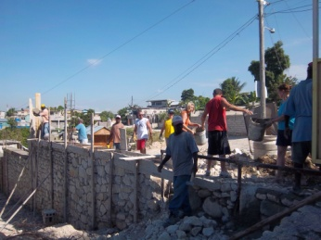
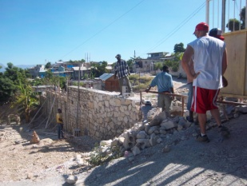
On Wednesday was a day of hard work. We visited Pastor Renes’s Project at Sielo, Haiti, where he has property where he has started a school. His vision is to have a church and a technical school, as well. He had started a security wall built around the property and this needed to be completed. We provided him with finances for the supplies to complete the exterior wall. Our team worked as a chain gang for the day and passed the cement mixture to the Haitian Masons in five gallon buckets.
After the day at Sielo, we were honored to be invited to an Haitian wedding and celebration dinner. Our team had a great time relaxing at the wedding after a day of hard work. Kirby, from the AFCA Tent City rode his bicycle to be with us for the evening.
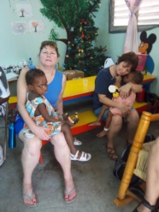
Upon returning to the guesthouse, a team member presented Kirby an envelope of money’s earned by a ten year old boy from Mineral Point, WI to be used for his chicken project. Kirby has come so far since we first met him in August of 2010.
On Thursday, we revisited the Grace Children’s Hospital, where we held the babies again. We noticed that they seemed to be feverish and not as alert as the previous visit. This was the visit where Vivian was able to meet with the Doctor concerning her autistic son.
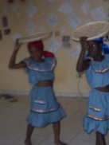
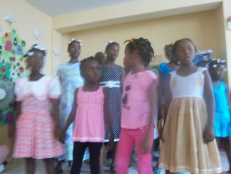
We then returned to the Choaids Orphanage where we were invited to celebrate World Aids Day with them. The children performed for us and other visitors in song and dances. They sang and danced from their hearts and we could feel the emotions they were sharing with us. It was a celebration of how far the understanding and medications have come for HIV patients. We were served sandwiches, cake and soda after the performance.
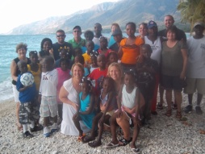
On Friday we were privileged to take the children on their first field trip to the beach. It was a long drive, but a day that was enjoyed by all swimming in the ocean. Dinner was ordered as a take out for all of us. On the return trip many were worn out from the day of activities and naps were taken.
After dinner that evening we had our final team meeting (one held each day) that lasted until 11:00 PM. This was an emotional time where each shared what they felt was the hi-light of the week for them, as well as what each person felt were the strengths of each team member.
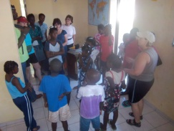
Saturday, began with part of the team traveling to see and say good-bye to the Orphans (very sad time). We prayed with them and let them know that each are loved and God has gifted each with a talent to share and a part of His plan. We delivered a Christmas Gift for each child to be given on Christmas Eve. This part of the team then visited downtown to the earthquake area, to see the Church and the Parliament Building. The only difference since we last visited in August 2010, is that the debris has been cleared out of the church. 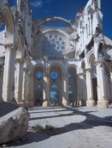Pastor Maxeau then took the team members to the top of the mountain, where we could see that all of Haiti is not poor. There we saw beautiful homes, and a clean area. From the top we could see all of Port au Prince.
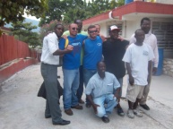
The remainder of the team members spent the day with the Orphans. This was a very emotional and sad time to say good-bye to them. Each one came away in tears, realizing that God has put these children here for a reason and we were able to share the time with them.
We all returned to the Guesthouse for lunch and to pack up for our return to the USA. Before getting in the truck to go to the Airport, Pastor Renes had us all (interpreters, drivers, Pastor Maxeau, Monique, the cooks, Marie and our team) hold hands together and they prayed for us and sang for us to have a safe trip back to our homes and to return again.
Returned home safely at 4:00 AM Sunday, December 4th, 2011.
What a great experience and thanks for the opportunity. The country, being so poor, continues to need our prayers and support.

